SAVE THE DATE
World AIDS Day Commemoration

December 1, 2015
5 pm
Criterion Theater
86 Temple Street, New Haven

Reception
Film “We’re Still Here”
Discussion with Grisell Granados and John Thompson

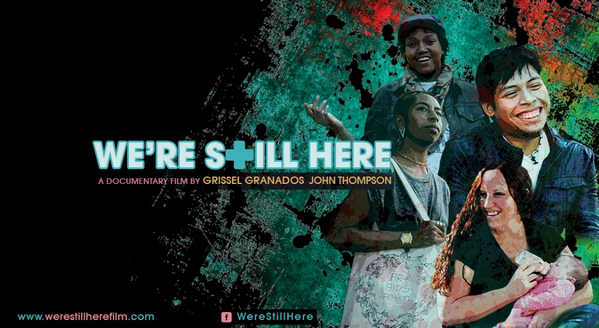
werestillherefilm
NewHavenCommunityWorldAIDSDay

FREE & OPEN TO THE PUBLIC
Sponsored by the New Haven Mayor’s Task Force on AIDS
Questions? Email Sandra.gossart-walker@yale.edu or jantunes@newreach.org

